36.63: For 6500 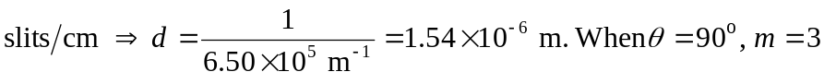 so one barely gets the 3rd order.

